

SAILMAKERS TO THE WORLD
Quote Request
Given Name:* Family Name:*
Email:*
Address:

Country:*
Phone at Work Home Fax
Delivery date at destination desired:
Shipment to be effected by: Air / Sea Port of Discharge:
* This information is required to process your quotation.
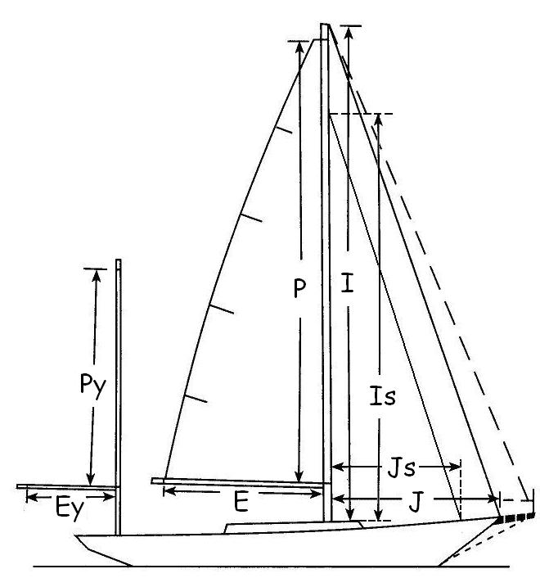
Boat Type:
Boat Length:
Usage: Cruising / Racing / Both
Average Wind Speed:
Upon ordering, please provide sailplan and Rating Certificate for racing sails, if possible.
Unit specified below are Meter / Feet
Fore triangle I or HGH^ J
Is Js
Mainsail P E
Mizzen Py Ey
Maximum Genoa Luff Hoist along forestay:
^HGH = Maximum Height of Genoa Hoist along mast.
Dimensions of Sails
Please give maximum dimensions wanted. Sail maker will make sails with allowance for eventual stretch as sails are used.
Luff Foot Leech Cloth Weight Battens Reefs
- Mainsail Full / Short / None
 Mizzen Full / Short / None
 Staysail Full / Short / None
- Jib Furling / Not Furling
 Genoa Furling / Not Furling



Downwind Luff Max Girth Remarks
 Spinnaker Furling / Not Furling Headsail
Usage: Type: Cutting:
- Cruising  Symmetrical  Radial Head
- Racing  Asymmetrical  Tri-Radial
 Star-cut
Addition Information

